Index

Contents
Index 1
1NC 3
1NC 4
1NC 5
1NC 6
Link – Generic – Alternative Energy 9
Link – Generic – Renewable Resources 10
Link – Generic - Efficiency 11
Link – Generic – Efficiency 12
Link – Advantage – Anthropocentricism 13
Link – Advantage – Critical Affs 14
Link – Advantage – Environmental Racism 15
Link – Advantage – Global Warming 16
Link – Advantage – Agriculture 17
Link – Advantage – Oil Dependency 18
Link – Advantage - Economy 19
Link – Advantage – Competiveness 20
Link – Advantage - Competiveness 21
Link – Wind Energy 22
Link – Solar Energy 23
Link – Nuclear Energy 24
Link – Space/Satellites 25
Impact - Totalitarianism 26
Impact – Nuclear Omnicide 27
Alternative – Meditative Thought 28
Alternative Solvency 30
Impact Overview 31
AT: Perm 32
AT: Heidegger is a Nazi 33
AT: Ethics Outweigh Ontology 34
AT: Tech Good 36
AT: Tech Good 37
AT: Postmodernism 38
AT: Krishna 39
Heidegger is a Nazi 40
Death Comes Before Ontology 41
Alt Fails 42
Alt Fails 43
Ethics are Good 44

1NC

The Aff’s attempt to “free” alternative energy from the sky, the water, and the earth is hard-wired into a project of western metaphysics founded on enframing – understanding nature and all its inhabitants as relevant only insofar as they are useful – the aff’s demand for alternative energy shifts the mode of consumption, not its overall justification, perpetuation a relation with nature and ourselves that is manipulative, violent and fragmented

Kinsella ’06 (Wiiliam, Ph.D Assistant Professor at North Carolina State University, “Heidegger and Being at the Hanford Reservation: Linking Phenomenology,
Environmental Communication, and Communication Theory”, http://www.allacademic.com//meta/p_mla_apa_research_citation/0/9/0/9/8/pages90982/p90982-1.php)

Heidegger’s concept of projection indicates that nature is always disclosed in light of its usefulness for Dasein’s practical activities. This characteristic of disclosure is fundamental and inevitable, and Heidegger is not critical of this human propensity to utilize the world. The technological attitude that he calls enframing, however, is a specific and problematic mode of utilization in which nature becomes a “standing reserve” (Heidegger, 1977c) or a “gigantic gasoline station, an energy source for modern technology and industry” (Heideggger, 1966, p. 50). Heidegger (1977c) illustrates this concept with a series of poignant examples: The revealing that rules in modern technology is a challenging…which puts to nature the unreasonable demand that it supply energy that can be extracted and stored as such. But does this not hold true for the old windmill as well? No. Its sails do indeed turn in the wind….But the windmill does not unlock energy from the air currents in order to store it.
A tract of land is challenged into the putting out of coal and ore. The earth now reveals itself as a coal mining district, the soil as a mineral deposit. Agriculture is now the mechanized food industry. Air is set upon to yield nitrogen, the earth to yield ore, ore to yield uranium…uranium is set upon to yield atomic energy. The coal that has been hauled out in some mining district has not been supplied in order that it may simply be present somewhere or other. It is stockpiled; that is, it is on call, ready to deliver the sun’s warmth that is stored in it. The sun’s warmth is challenged forth for heat, which in turn is ordered to deliver steam whose pressure turns the wheels that keep a factory running. The hydroelectric plant is set into the current of the Rhine….In the context of the interlocking processes pertaining to the orderly disposition of electrical energy, even the Rhine appears as something at our command….What the river is now, namely, a water power supplier, derives from out of the essence of the power station….But, it will be replied, the Rhine is still a river in the landscape, is it not? Perhaps. But how? In no other way than as an object on call for inspection by a tour group ordered there by the vacation industry (pp. 14-16). 8 These examples do not reflect mere nostalgia. Instead, they illustrate a radical break in Dasein’s relationship with the earth. That relationship is now characterized by calculation, control, and deliberate disruption of the natural order. Indeed, in the last two of these examples the natural order is displaced when steam and a tour group are “ordered,” and ambiguously, this ordering can be understood as a calculated physical arrangement but also as an imperative command. I suspect that this same ambiguity is present in the original German text, and that Heidegger was well aware of its presence.

1NC

Order is founded on disorder – the reduction of the sky, earth and seas to “energy” creates a realm of the master that is ironically beyond the capacity for mastery – the illusion of control over neutral tools masks how such a relation to the world shapes us into objects, creating a mass delusion of management that precludes our ability to relate as part of the world
Beckman 2000 (Tad, Ph.D. HMC professor, “Heidegger and Environmental Ethics”, page 1 – 5, http://www2.hmc.edu/~tbeckman/personal/HEIDART.HTML)

To understand the essence of modern technology as enframing, Heidegger claims is to understand the problem of technology in its fullest sense; for in enframing we will understand the deeper context in which humans journeyed from involvement with nature into an intrusion upon it. We must move, then, to understand what Heidegger meant by enframing. We are to understand technology through enframing in two very important ways. First, technology is a process, or coming-to-presence, which is underway in the world and which has truly gigantic proportions. The two concepts that Heidegger used as analogies in arriving at the word 'Ge-stell' were 'Gebirg" and 'Gemuet.' Both of these are processes of cosmic scope. The former is the gradual building, emergence, folding, and eroding of a mountain range. The latter is the welling up and building of emotional feelings that originate in the depths of our beings, as differentiated from the simple emotions that arise quickly and spontaneously in normal contexts. Second, technology viewed as enframing is a process that is shaping human destiny today and that has been shaping human destiny in relation to the universe for almost as long as we conceive of our history. What we call technology and think to be a neutral instrument standing ready for our control is actually a specific manifestation of this whole process. {[7], p. 19} The concept of enframing suggests that human life in the context of the natural world is gathered wholly and cosmically within the essence of technology. Just as the technology that we now see ongoing in the world shows the characteristic of challenging-forth the objects around us, the whole process within which human life is developing challenges-us-forth to this mode of revealing the real or of ordering nature into standing reserve. Our control over technology is an illusion; it and we alike are being shaped, like an evolving mountain range, in the process that Heidegger called enframing. The possession of what we commonly call technology is only a fragmentary, though characteristic, aspect of that whole development; language thought, religion, art, and all other aspects of human life are coordinated into this development as a part of enframing. To see the essence of technology in this way delivers us into the final phase of Heidegger's analysis, the great danger to humanity that technology represents. Just as enframing organizes our lives progressively into a disposition of challenging and ordering the things around us into standing reserve, its progress as a development of human destiny challenges and orders us into standing reserve for its own ends. "The destining of revealing is in itself not just any danger, but danger as such. Yet when destining reigns in the mode of Enframing, it is the supreme danger. This danger attests itself to us in two ways. As soon as what is unconcealed no longer concerns man even as object, but does so, rather, exclusively as standing-reserve, and man in the midst of objectlessness is nothing but the orderer of standing-reserve, then he comes to the very brink of a precipitous fall; that is, he comes to the point where he himself will have to be taken as standing-reserve. Meanwhile, man, precisely as the one so threatened, exalts himself to the posture of lord of the earth. In this way the impression comes to prevail that everything man encounters exists only insofar as it is his construct. This illusion gives rise in turn to one final delusion: It seems as though man everywhere and always encounters only himself."

1NC

Such a fantasy-ridden understanding of our own capacities to know and own the energy of nature reduces human beings to blind energy-consumers, as our aspirations for limitless consumption unleash a slow-motion ecological devastation worse than nuclear omnicide
Zimmerman ’97 (Michael, Contesting Earth's Future: Radical Ecology and Postmodernity, Berkeley, Calif. University of California Press, 1997. p.119-120

Heidegger asserted that human self-assertion, combined with the eclipse of being, threatens the relation between being and human Dasein.⁵³ Loss of this relation would be even more dangerous than a nuclear war that might "bring about the complete annihilation of humanity and the destruction of the earth."⁵⁴ This controversial claim is comparable to the Christian teaching that it is better to forfeit the world than to lose one's soul by losing one's relation to God. Heidegger apparently thought along these lines: it is possible that after a nuclear war, life might once again emerge, but it is far less likely that there will ever again occur an ontological clearing through which such life could manifest itself. Further, since modernity's one-dimensional disclosure of entities virtually denies them any "being" at all, the loss of humanity's openness for being is already occurring.⁵⁵ Modernity's background mood is horror in the face of nihilism, which is consistent with the aim of providing material "happiness" for everyone by reducing nature to pure energy.⁵⁶ The unleashing of vast quantities of energy in nuclear war would be equivalent to modernity's slow-motion destruction of nature: unbounded destruction would equal limitless consumption. If humanity avoided nuclear war only to survive as contented clever animals, Heidegger believed we would exist in a state of ontological damnation: hell on earth, masquerading as material paradise. Deep ecologists might agree that a world of material human comfort purchased at the price of everything wild would not be a world worth living in, for in killing wild nature, people would be as good as dead. But most of them could not agree that the loss of humanity's relation to being would be worse than nuclear omnicide, for it is wrong to suppose that the lives of millions of extinct and unknown species are somehow lessened because they were never "disclosed" by humanity.

1NC

Alternative- Vote negative.

The call to do nothing illuminates a paradoxical path that opens the possibility for a new model of thinking that allows the world the show itself on its own terms.
McWhorter ’92 (John, Ph.D – Stanford, professor, Heidegger and the earth, 1992, pg. 4-7)

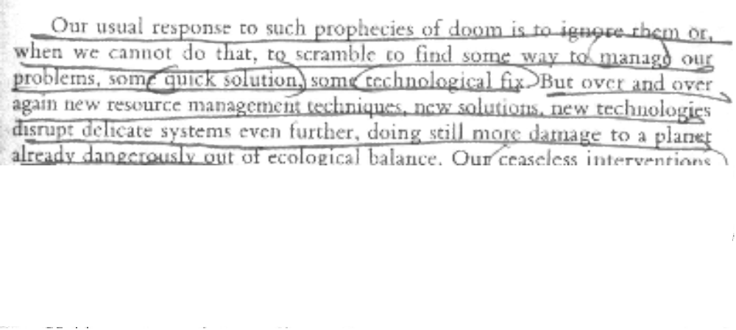CNTD…

1NC

CNTD----------

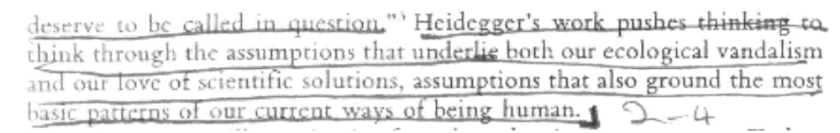
Link – Generic – Calculative Thought

The enframing of nature in the lens of manipulation and control precludes our ability to relate to our position in and with the earth and thus our relation with ourselves

Kinsella ’06 (Wiiliam, Ph.D Assistant Professor at North Carolina State University, “Heidegger and Being at the Hanford Reservation: Linking Phenomenology,
Environmental Communication, and Communication Theory”, http://www.allacademic.com//meta/p_mla_apa_research_citation/0/9/0/9/8/pages90982/p90982-1.php)

Heidegger believed that the reduction of nature to a standing reserve alienates us not only from the elements of our environment, but also from our own most fundamental attribute, our very being. 2 Human being—understood by Heidegger as both actor and activity—is always being-in-the-world, involving continuing engagement with the other phenomena of that world. To be authentic(ally), this engagement requires meeting the world not only on our terms, but also on its own terms; only through such meeting can we realize true being. Linking this concept of being to the problematic of technology, Heiddeger (1977c) suggested that “the essence of technology is by no means anything technological” (p. 4); rather, it is manifested in modes of thinking, language, and action that are oriented toward enframing. These approaches alienate us from the radical otherness of the phenomena that surround us, disabling the possibilities for authentic being. Well aware of the hazards posed by nuclear weapons and nuclear wastes, Heidegger nevertheless saw an even greater threat in the prospect that human being might be reduced, along with the rest of nature, through the modality of enframing: The threat to man does not come in the first instance from the potentially lethal machines and apparatus of technology….The rule of Enframing threatens man with the possibility that it could be denied to him to enter into a more original revealing and hence to experience the call of a more primal truth (Heidegger, 1977c, p. 28).

Link – Generic – Alternative Energy
The affirmative's portrayal of alternative energy objectifies nature by attempting to store it and use it to fuel modern technology.
Hoover and Lundby 97 [Stewart M. Hoover and Knut Lundby 1997, Rethinking Media, Religion, and Culture, Page 72. Hoover directs the Symbolism, Media and the Lifecourse Study. He earned his Ph.D. in mass communication at the University of Pennsylvania and also holds an M.A. in ethics. Lundby is a Professor at the Department of Media and Communication, University of Oslo.]
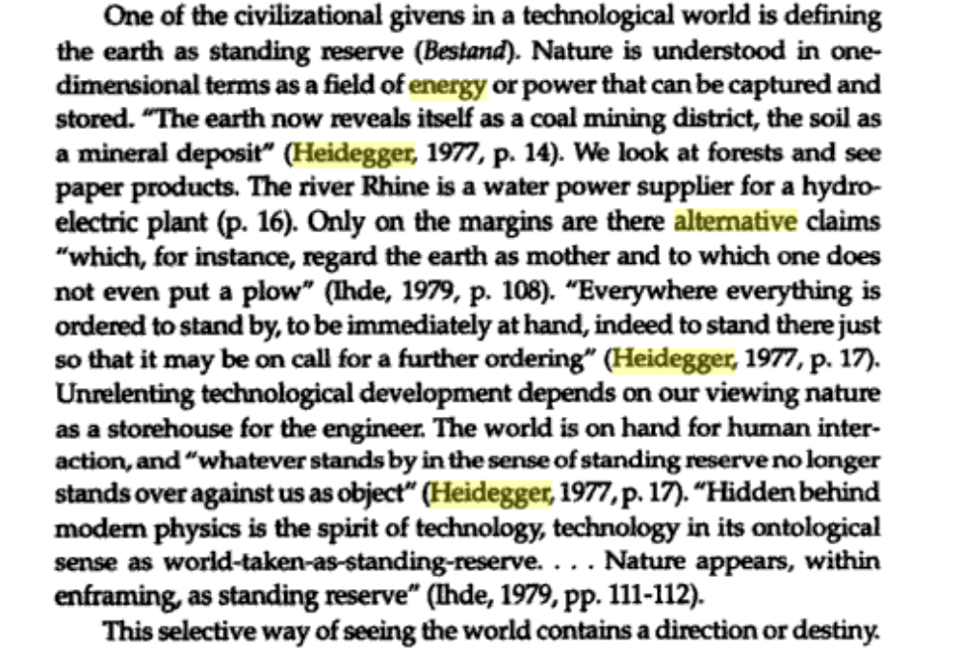

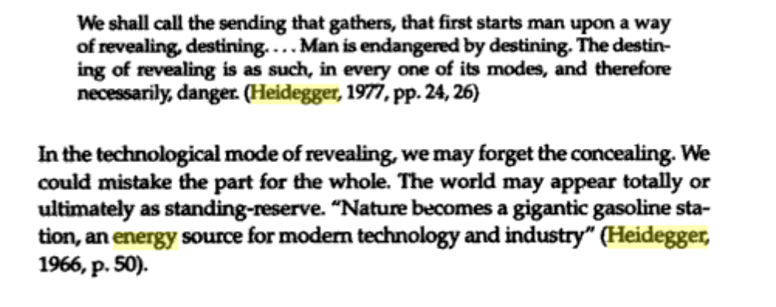

Link – Generic – Renewable Resources

Focusing on simply using cleaner energy without questioning our consumptive continues our objectification of self and world

The Huffington Post 2008 . (Rebekah and Stephen Hren, "Solving Energy Crisis with Renewables Could Lead to Ecological Collapse", July 19 2008, The Huffington Post, < http://www.huffingtonpost.com/rebekah-and-stephen-hren/solving-energy-crisis-wit_b_113812.html>.)

Lost amongst all the "solutions" to the energy crisis lies the fact that the energy crisis is simply one component of a much broader ecological crisis. Addressing the energy issue in isolation and attempting to solve only this one aspect could easily exacerbate many of the other ecological problems we now face. Our true crisis is one of over-consumption. This is not limited to supplies of fossil energy, but affects every component of the earth's biosphere. We are cutting down too many forests, sprawling out on too much arable land, dumping too many poisons into our waterways, pumping out too much dirty air (especially CO2), sucking up too much water; the list could go on for a very long time, but I'll stop there. Energy is, of course, the means by which we consume all these other resources. The fact that we now use dirty energy rather than clean energy to consume these resources is, ultimately, not that important. Turning our dirty energy sources into clean ones is important for mitigating global climate disruption, but if this allows us to continue down the path of over-consumption of everything else that sustains life on this planet, then renewable energy will simply be the enabler that allowed our misguided species to continue its ultimate destruction of the most amazing thing in the universe: Planet Earth. We have, unfortunately, set up a system of values, reflected in our economic system, that prizes material goods above everything else. Not just prized above every other species we share the globe with but prized even above our own happiness. We have reached the limits of our ability to consume and have still not obtained happiness. Rather than see these limits as barriers to be removed so we can consume yet more, we should reconsider the assumptions and foundations that have led us to this crisis point. Renewable energy, yes, of course, but only in moderation. Our notions of egalitarianism, based on the fundamental principle that we are all equal, insists that our own way of life does not infringe on other people's ability to provide for themselves. A world of seemingly limitless resources has allowed us to pretend that our own consumption does not affect anyone else's. But we have now grown numerous and powerful enough to see that limitless consumption on a finite planet is an impossibility. Everything we consume in an unsustainable way means there's that much less available for everyone else. Only five percent of the world has ever flown in an airplane. Only 15% has access to a private car. Imagine the implications if everyone on the globe had access to these things.In times of crisis, we must demand more not just from ourselves, but also from our leaders. The earth has not seen such a crisis since the dinosaurs went extinct, so our expectations must be very high. After having spent the last eight years or so suffering under the worst president in our history, it's easy to get excited about almost anyone who might replace him. Can Mr. Obama, if elected, dislodge our system of government from the notions of endless consumption to which it now seems hopelessly conjoined? Or will he simply apply a few band-aids to the hemorrhage? Mr. Obama seems like an extraordinary man, perhaps the best our political system is capable of producing. If he cannot begin to steer our country in a sustainable direction, not just in terms of energy but also in everything else we consume, then I suggest the time will have come to reconsider the foundations upon which our society is governed. As a society, we must not become fixated on one aspect of the over-consumption problem (dirty energy) to the detriment of all the rest (water, topsoil, species extinction, logging, etc). We must, of course, embrace renewable energy and rid ourselves of fossil fuels as quickly as possible. I believe Mr. Gore's goal of a carbon-free nation can be reached by 2020, but not if we're consuming other nonrenewable resources at the same level as we do now. Individually we need to reexamine our own lives not just in terms of our excessive energy use, but our over-consumption generally. There are few people in our country, ourselves included, that could not dramatically reduce their ecological footprint, not just their carbon footprint.

Link – Generic - Efficiency

Our obsession with technological efficiency forces our will on nature in an increasingly aggressive, regulatory mode.
Kaplan 4 [David M. Kaplan, Ph.D. Assistant Professor of Philosophy. University of North Texas 2004 Readings in the Philosophy of Technology page 3-4]
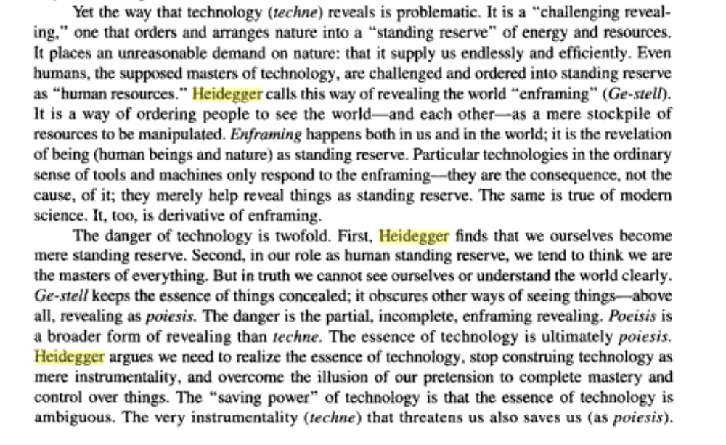
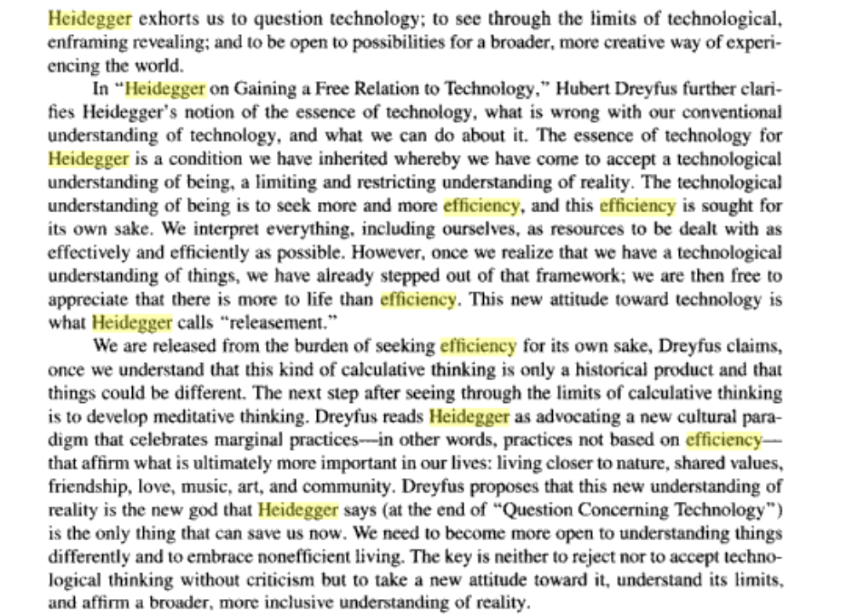

Link – Generic – Efficiency

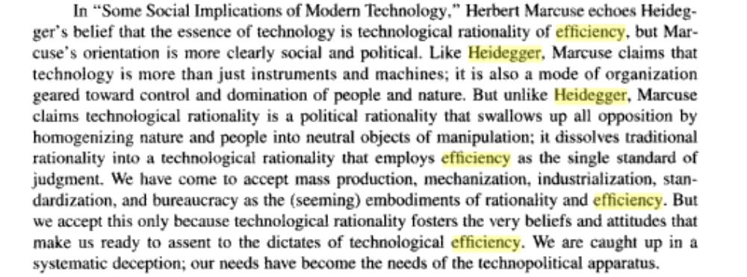

Link – Advantage – Anthropocentricism

THE AFF’S MOTIVATION TO END ANTHROPOCENTRICISM IS SO HUMANS CAN EXPLOIT NATURE FOR ITS RESOURCES

Tabachnick 2002 (David, Heidegger’s Essentialist Responses to the Challenge of Technology, Ph.D., Professor Nipissing University, project muse)

The first stasis point revolves around humanity's relation to nature. To put it plainly, in environmental circles it is still a Cartesian world, wherein the founding act is human thinking (cogito ergo sum) and the [End Page 71] earth is object to humanity's subject. This position is clear in mainstream environmentalism, where humans act to save the object earth and, fundamentally, this action is motivated by the subject's self-interest. So, we must save the rain forests because they contain potential medical resources and because they alleviate global warming. Now certainly this base anthropocentrism has come under attack from various radical environmentalisms that posit biocentrism or ecocentrism. I would argue, however, that these anti-anthropocentric positions have not escaped the gravity of Cartesianism. This is evident at both theoretical and practical levels. Theoretically, in the effort to avoid the stain of anthropocentrism all beings are posited as having equal intrinsic worth/value and difference is leveled. The banana slug is equal to homo sapiens. There are problems with this. Most obviously, the concept of intrinsic worth/value is philosophically incoherent—worth/value by definition is always relational. More significantly for this discussion, to posit intrinsic worth/value is to deny the ecological insight that all beings are constituted in relation to other beings and their environment. Further, to deny difference is to blunt analysis of our current situation and to deny the differential levels of effects different species have. Homo sapiens is not another type of slug and must be analyzed with that awareness. In practice, radical groups, most notably Earth First!, often demonize humans as a cancer on the planet. As the metaphor suggests, humans are seen as somehow different from all other forms of life, an alien other, not a part but apart. Even more significantly, the metaphor of cancer suggests humans to be active subjects preying on the object earth. Indeed, the problem with humanity, as with the cancer cell, is that it is too active. Although radical groups offer a different valuation, note that this position does not trouble the terms of Cartesianism. The dichotomies subject-object, human-animal, culture-nature, civilization-wilderness, remain intact. The active subject humanity threatens the object earth. The statsis point in actual environmental debates revolves around reform and radical environmental groups dismissing each other's seemingly oppositional positions as, respectively, anthropocentic and compromised versus misanthropic and unrealistic, while remaining oblivious to the underlying Cartesian presuppositions they both share. In other words, reform environmentalists privilege humanity while radical environmentalists demonize humanity. In this morality play on the fate of the [End Page 72]planet, humanity, whether hero or villain, is the actor. Heidegger's thinking on the subject-object dichotomy, Descartes, and the phenomenology of the structure of reality offer a useful lever with which to displace these dichotomies and challenge the traditional ontology that undergirds and girdles environmental thinking.

Link – Advantage – Critical Affs

THE AFF’S PLAN IS JUST A REASSERTION OF TECHNOLOGICAL DREAMS CAUSED BY PREVIOUS MISMANAGEMENT

McWhorter ’92 (John, Ph.D – Stanford, professor, Heidegger and the earth, 1992, pg. 4-7)

Link – Advantage – Environmental Racism
The framing of humans as a pest on the planet enframes the human race as below the environment – this mindset still does not allow us to relate with the earth.

Deluca 2005 (Kevin Michael, PhD in Communicatons and professor at University of Virginia, Rethinking Environmental Theory and Practice, project muse)

Yet even the practices of radical grassroots groups that eschew central organization and its attendant dangers deserve scrutiny. Beginning with Greenpeace in the 1970s and intensifying in the 1980s with the emergence of wilderness and environmental justice groups, the radical environmental movement has increasingly relied on managing images and manipulating media, in fact practicing what could be considered an oppositional grassroots public relations. If public relations, along with advertising, is the discourse of machination, a discourse of empty words in service of giganticism (bigger is better) and progress (newer is better), what are the consequences when radical environmental groups deploy that very discourse in efforts to reach the public through mass media? What are the consequences when Greenpeace champions the cause of furry baby harp seals at the neglect of less photogenic indicator species? Are the effects of this any different from when the much more compromised World Wildlife Fund (WWF) adopts the panda as its symbol and cause celebre? What are the consequences when Earth First!, the environmental justice group Kentuckians For The Commonwealth, and other grassroots groups conform to the constraints of the mass media (stunning images, sound bites, conflict focus, emotional appeals, and so on) and deploy the practices of public relations in order to stage image events? Is it possible to fundamentally challenge machination while using the techniques of machination? These are not rhetorical questions. I do not have the answers and I do not think there are easy answers. Instead, Heidegger offers the environmental movement the admonishment to question what it takes for granted, to think about the presuppositions and practices that are reflexively deployed as a matter of course.

Link – Advantage – Global Warming

ATTEMPTS TO REDUCE GLOBAL WARMING IS FUTILE- THE ACTIONS ARE ROOTED IN TECHNOLOGICAL THOUGHT

Hill’ 07 (Glenn,“DESIGN WITHOUT CAUSALITY: HEIDEGGER’S IMPOSSIBLE CHALLENGE FOR ECOLOGICALLY SUSTAINABLE ARCHITECTURE”, http://epress.lib.uts.edu.au/dspace/handle/2100/474)
At this point, the implications for ecological sustainability and for design also become clear.
With modernity’s belief that causality in nature could be understood and therefore controlled,
technologies have been increasingly deployed with the confidence that their outcomes can be
predicted. While the design of each individual technologically mediated intervention would have
been intended to cause a (local) beneficial outcome for some portion of humanity (grounded in
‘care’ in Heidegger’s terms), their cumulative impact on the ecological systems of the planet is
now considered by many to be potentially catastrophic. If this scenario is accepted, then design
could be characterised as the well-intentioned engine driving the proliferation of technologies
that now threatens the planet.
Designers, and not least architects, are enframed within a view of causality which instils
confidence that designed outcomes have predictable effects. Tellingly, this confidence is no
less evident in the responses to the perceived ecological crisis, where design is confidently
being advocated to develop solutions to overcome the very problems that confident designing
has created. Confirming such a view of the designer, Heidegger refers to the ‘engineer in his
drafting room’ (which could equally be the architect in his/her studio) as being part of an
enframed system, ‘an executer, within Enframing’ (Question, 29).
Modernity’s understanding that the entities constituting our universe are a particular way and
operate under the rule of causality, marks a momentous shift: in pre-modernity nature is
apprehended as mysterious and marvellous; in modernity nature is apprehended as systematic
and operable. This shift is, for me, no better illustrated than in the surreal (yet quite serious)
design for a solar umbrella consisting of trillions of satellites launched from earth and intended
to stop global warming (Brahic). The pre-modern understanding of the mystery and wonder of
the sun’s warmth granting life to all beings on earth (for many pre-modern cultures the sun and
God were one), has shifted to a modern understanding where the sun’s warming of the earth is
a calculable system that we do not merely believe we can understand, but have the hubris to
believe that we can control.

Link – Advantage – Agriculture

Agriculture engineers and manipulates nature.
Rojcewicz 6 [Richard, Professor of Philosophy at Point Park University 2006, The Gods and Technology: A Reading of Heidegger Page 77]

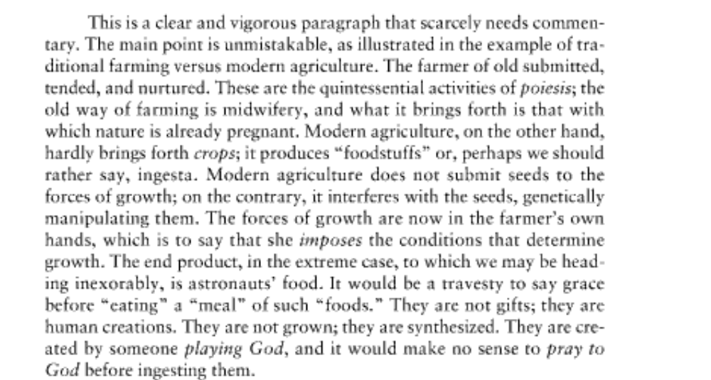

Link – Advantage – Oil Dependency

THE AFF’S ATTEMPT TO “FREE” THE U.S. FROM OIL DEPENDENCY MERELY SHIFTS THE TECHNOLOGICAL ATTITUDE TOWARDS NEW VENUES, SANITIZING PRACTICES THAT REDUCE THE WORLD TO A STANDING RESERVE

Kinsella ’06 (Wiiliam, Ph.D Assistant Professor at North Carolina State University, “Heidegger and Being at the Hanford Reservation: Linking Phenomenology,
Environmental Communication, and Communication Theory”, http://www.allacademic.com//meta/p_mla_apa_research_citation/0/9/0/9/8/pages90982/p90982-1.php)

Heidegger’s concept of projection indicates that nature is always disclosed in light of its usefulness for Dasein’s practical activities. This characteristic of disclosure is fundamental and inevitable, and Heidegger is not critical of this human propensity to utilize the world. The technological attitude that he calls enframing, however, is a specific and problematic mode of utilization in which nature becomes a “standing reserve” (Heidegger, 1977c) or a “gigantic gasoline station, an energy source for modern technology and industry” (Heideggger, 1966, p. 50). Heidegger (1977c) illustrates this concept with a series of poignant examples: The revealing that rules in modern technology is a challenging…which puts to nature the unreasonable demand that it supply energy that can be extracted and stored as such. But does this not hold true for the old windmill as well? No. Its sails do indeed turn in the wind….But the windmill does not unlock energy from the air currents in order to store it.
A tract of land is challenged into the putting out of coal and ore. The earth now reveals itself as a coal mining district, the soil as a mineral deposit. Agriculture is now the mechanized food industry. Air is set upon to yield nitrogen, the earth to yield ore, ore to yield uranium…uranium is set upon to yield atomic energy. The coal that has been hauled out in some mining district has not been supplied in order that it may simply be present somewhere or other. It is stockpiled; that is, it is on call, ready to deliver the sun’s warmth that is stored in it. The sun’s warmth is challenged forth for heat, which in turn is ordered to deliver steam whose pressure turns the wheels that keep a factory running. The hydroelectric plant is set into the current of the Rhine….In the context of the interlocking processes pertaining to the orderly disposition of electrical energy, even the Rhine appears as something at our command….What the river is now, namely, a water power supplier, derives from out of the essence of the power station….But, it will be replied, the Rhine is still a river in the landscape, is it not? Perhaps. But how? In no other way than as an object on call for inspection by a tour group ordered there by the vacation industry (pp. 14-16). 8 These examples do not reflect mere nostalgia. Instead, they illustrate a radical break in Dasein’s relationship with the earth. That relationship is now characterized by calculation, control, and deliberate disruption of the natural order. Indeed, in the last two of these examples the natural order is displaced when steam and a tour group are “ordered,” and ambiguously, this ordering can be understood as a calculated physical arrangement but also as an imperative command. I suspect that this same ambiguity is present in the original German text, and that Heidegger was well aware of its presence.

Link – Advantage - Economy

THE AFF’S ATTEMPT TO ADVANCE THE ECONOMY IS TO ESTABLISH TECHNOLOGICAL CONTROL ON MONETARY VALUE

Hanspeter Padrutt, psychiatrist, Daseinanalytisches Institut, Zurich, HEIDEGGER AND THE EARTH, Ladelle McWhorter, ed., 1992, p.27.

Just as problematic as natural science's reduction of all beings in the concept of energy is, so too is the economic reduction of all beings to a monetary value problematic. Certainly the proposals for economic decentralization and for the development of a softer technology made by the British economist E. F. Schumacher (author of Small is Beautiful) are as relevant today as ever. Certainly the provocative theses of an Ivan Illich are in many ways very pertinent. And probably an ecological economy will develop presumably in the direction of James Robertson's "alternatives worth living." But one cannot overlook the fact that an ecological accounting still reduces things to a monetary value and that many concepts of these authors are characterized by the economy of objectifying subjectivism, by a woridview of the retailers - as, for example, the concept of a "qualitative growth."

Link – Advantage – Competiveness

Environmentalism uses the same appeals of consumption and economic utilization to commodify the ecological systems into economic worths; preservation only occurs to further the eventual exploitation that fuels our capitalistic, consumer economy.
Luke, 1997. (Timothy W. Luke, Department of Political Science, Virginia Polytechnic Institute and State University, Blacksburg VA, "The (Un)Wise (Ab)Use of Nature: Environmentalism as Globalized Consumerism?", International Studies Association, March 18-22 1997, < http://www.cddc.vt.edu/tim/tims/Tim528.PDF>, pages 3-5.)

A political, economic, and technical incitement to talk about ecology, environments, and Nature, first surfaced as the
social project of "environmentalism" during the 1960s in the United States, but it plainly has become far more pronounced in the 1990s. Not much of this takes the form of general theory, because most of its practices have been instead steered toward analysis, stock taking, and classification in quantitative, causal, and humanistic studies. Nonetheless, one can follow Foucault by exploring how mainstream environmentalism in the United States operates as "a whole series of different tactics that combined in varying proportions the objective of disciplining the body and that of regulating populations."3 The project of "sustainability," whether one speaks of sustainable development, growth or use in relation to Earth's ecologies, embodies this new responsibility for the life processes in the American state's rationalized harmonization of political economy with global ecology as a form of green geo-politics.

These interconnections become even more intriguing in the aftermath of the Cold War. Having won the long twilight struggle against communist totalitarianism, the United States is governed by leaders who now see "Earth in the balance," arguing that global ecologies incarnate what is best and worst in the human spirit. On the one hand, economists, industrialists, and political leaders increasingly tend to represent the strategic terrain of the post-1991 world system as one on which all nations must compete ruthlessly to control the future development of the world economy by developing new technologies, dominating more markets, and exploiting every national economic asset. However, the phenomenon of "failed states," ranging from basket cases like Rwanda, Somalia or Angola to crippled entities like Ukraine, Afghanistan or Kazakhstan, often is attributed to the severe environmental frictions associated with the (un)wise (ab)use of Nature by ineffective strategies for creating economic growth.4 Consequently, environmental protection issues--ranging from resource conservation to sustainable development to ecosystem restoration--are getting greater consideration in the name of creating jobs, maintaining growth, or advancing technological development.
4

Taking "ecology" into account, then, creates discourses on "the environment" that derive not only from morality, but from rationality as well. As humanity has faced "the limits of growth" and heard "the population bomb" ticking away, ecologies and environments became something more than what one must judge morally; they became things that state must administer. Ecology has evolved into "a public potential; it called for management procedures; it had to be taken charge of by analytical discourses," as it was recognized in its environmentalized manifestations to be "a police matter"--"not the repression of disorder, but an ordered maximization of collective and individual forces."5

Discourses of "geo-economics," as they have been expounded more recently by voices as diverse as Robert Reich, Lester Thurow, or Edward Luttwak, as well as rearticulations of "geopolitics" in an ecological register, as they have been developed by President Bill Clinton or Vice President Al Gore, both express new understandings of the earth's economic and political importance as a site for the orderly maximization of many material resources.6 Geo-economics, for example, often transforms through military metaphors and strategic analogies what hitherto were regarded as purely economic concerns into national security issues

Link – Advantage – Competiveness

of wise resource use and sovereign property rights. Government manipulation of trade policy, state support of major corporations, or public aid for retraining labor all become vital instruments for "the

continuation of the ancient rivalry of the nations by new industrial means."7 The relative success or failure of national economies in head-to-head global competitions typically are taken by geo-economics as the definitive register of any one nation-state's waxing or waning international power as well as its rising or falling industrial competitiveness, technological vitality, and economic prowess. In this context, many believe that ecological considerations can be ignored, or given at best only meaningless symbolic responses, in the quest to mobilize as private property as many of the earth's material resources as possible. This hard-nosed response is the essence of "wise use." In the on-going struggle over economic competitiveness, environmental resistance even can be recast by "wise use" advocates as a type of civil disobedience, which endangers national security, expresses unpatriotic sentiments, or embodies treasonous acts.

Geo-economics takes hold in the natural resource crises of the 1970s. Arguing, for example, that "whoever controls world resources controls the world in a way that mere occupation of territory cannot match," Barnet in 1979 asked, first, if natural resource scarcities were real and, second, if economic control over natural resources was changing the global balance of power.8 After surveying the struggles to manipulate access to geo-power
5
assets, like oil, minerals, water, and food resources, he did see a new geo-economic challenge as nation-states were being forced to satisfy the rising material expectations of their populations in a much more interdependent world system.9 Ironically, the rhetorical pitch of Reich, Thurow and Luttwak in the geoeconomics debate of the 1990s mostly adheres to similar terms of analysis. Partly a response to global economic competition, and partly a response to global ecological scarcities, today's geoeconomic reading of the earth's political economy constructs the attainment of national economic growth, security, and prosperity as a zero-sum game. Having more material wealth or economic growth in one place, like the U.S.A., means not having it in other places, namely, rival foreign nations. It also assumes material scarcity is a continual constraint; hence, all resources, everywhere and at any time, are private property whose productive potentials must be subject ultimately to economic exploitation.

Geo-economics accepts the prevailing form of mass market consumerism as it presently exists, defines its many material benefits as the publicends that advanced economies ought to seek, and then affirms the need for hard discipline in elaborate programs of productivism, only now couched within rhetorics of highly politicized national competition, as the means for sustaining mass market consumer lifestyles in advanced nations like the United States. Creating economic growth, and producing more of it than other equally aggressive developed and developing countries, is the sine qua non of "national security" in the 1990s. As Richard Darman, President Bush's chief of OMB declared after Earth Day in 1990, "Americans did not fight and win the wars of the twentieth century to make the world safe for green vegetables."10 However, not everyone sees environmentalism in this age of geo-economics as tantamount to subversion of an entire way of life tied to using increased levels of natural resources to accelerate economic growth.

Link – Wind Energy

WIND ENERGY IS AN ATTEMPT FOR HUMANS TO TECHNOLOGICALLY CONTROL NATURE TO A STANDING RESERVE

Beckman 2000 (Tad, Ph.D. HMC professor, “Heidegger and Environmental Ethics”, page 1 – 5, http://www2.hmc.edu/~tbeckman/personal/HEIDART.HTML)

Heidegger clearly saw the development of "energy resources" as symbolic of this evolutionary path; while the transformation into modern technology undoubtedly began early, the first definitive signs of its new character began with the harnessing of energy resources, as we would say. (7) As a representative of the old technology, the windmill took energy from the wind but converted it immediately into other manifestations such as the grinding of grain; the windmill did not unlock energy from the wind in order to store it for later arbitrary distribution. Modern wind-generators, on the other hand, convert the energy of wind into electrical power which can be stored in batteries or otherwise. The significance of storage is that it places the energy at our disposal; and because of this storage the powers of nature can be turned back upon itself. The storing of energy is, in this sense, the symbol of our over-coming of nature as a potent object. "...a tract of land is challenged into the putting out of coal and ore. The earth now reveals itself as a coal mining district, the soil as a mineral deposit." {[7], p. 14} This and other examples that Heidegger used throughout this essay illustrate the difference between a technology that diverts the natural course cooperatively and modern technology that achieves the unnatural by force. Not only is this achieved by force but it is achieved by placing nature in our subjective context, setting aside natural processes entirely, and conceiving of all revealing as being relevant only to human subjective needs. The essence of technology originally was a revealing of life and nature in which human intervention deflected the natural course while still regarding nature as the teacher and, for that matter, the keeper. The essence of modern technology is a revealing of phenomena, often far removed from anything that resembles "life and nature," in which human intrusion not only diverts nature but fundamentally changes it. As a mode of revealing, technology today is a challenging-forth of nature so that the technologically altered nature of things is always a situation in which nature and objects wait, standing in reserve for our use. We pump crude oil from the ground and we ship it to refineries where it is fractionally distilled into volatile substances and we ship these to gas stations around the world where they reside in huge underground tanks, standing ready to power our automobiles or airplanes. Technology has intruded upon nature in a far more active mode that represents a consistent direction of domination. Everything is viewed as "standing-reserve" and, in that, loses its natural objective identity. The river, for instance, is not seen as a river; it is seen as a source of hydro-electric power, as a water supply, or as an avenue of navigation through which to contact inland markets. In the era of techne humans were relationally involved with other objects in the coming to presence; in the era of modern technology, humans challenge-forth the subjectively valued elements of the universe so that, within this new form of revealing, objects lose their significance to anything but their subjective status of standing-ready for human design. (8) At this point, we have almost completed the analysis of modern technology in its essence.

Link – Solar Energy

Turn – Solar energy has devastating environmental impacts – laundry list
Huesemann 2
[Michael H. Huesemann, Ph. D. Marine Science Laboratory, Pacific Northwest National Laboratory Received: 16 August 2002 Accepted: 29 October 2002 Published online: 14 December 2002 The limits of technological solutions to sustainable development
http://www.springerlink.com/content/bd6tbkx8r4va03rc/fulltext.html#ContactOfAuthor1]
It has been commonly assumed that renewable energy generation is more environmentally friendly than the use of nonrenewable energy sources such as fossil fuels or nuclear power (Hayes 1977, Lovins 1977, Brower 1992, Boyle 1996). While this assumption may be correct, it must be realized that the capture and conversion of solar energy will have significant negative environmental impacts, especially if they are employed on such a large scale as to supply nearly 100% of the U.S. energy demand (Abbasi et al. 1995, Trainer 1995a). Before discussing some of the potential negative impacts of different solar energy technologies, it is useful to review the implications of the second law of thermodynamics in order to show that environmental impacts of renewable energy generation are inherently unavoidable. This is because the flux of solar energy (or neg-entropy) onto Earth is used to create highly ordered (i.e., low entropy) so-called "dissipative structures" in the environment (Nicolis and Prigogine 1977, Atkins 1984, Ayres 1998a). Evidence of such structures can be seen in the complexity of organisms, ecosystems, biodiversity, and carbon and nitrogen cycles, all of which are maintained by the constant in-flow of solar energy (Ayres and Martinas 1995). If the flow of solar energy were to stop, as it ultimately will in a few billion years, all these complex structures would decay and reach a final equilibrium state where entropy is maximized. Similarly, if humans divert a fraction of solar energy away from the environment to create ordered structures for their own purposes (i.e., houses, appliances, transportation infrastructure, communication systems, etc.), less energy is available to maintain highly ordered dissipative structures in nature. The disturbance of these structures translates into the various environmental impacts that are associated with renewable energy generation. As shown in Fig. 3, the total amount of solar energy (ΔE s) that is received on Earth can be viewed as the sum of energy diverted for human purposes (ΔE h) and energy that remains available to maintain "order" in the environment (ΔE e): According to the second law of thermodynamics, energy (ΔE) is used to decrease the entropy (ΔS) (increase the order) of a system at temperature T [K] according to (Faber et al. 1995): Combining Eqs. (2) and (3) yields: where ΔS e and ΔS h are the change in entropy (order) in the environment and human-dominated sub-system, respectively. Combining Eqs. (2) and (4), it follows that a change of entropy in the environment is related to a change of entropy in the human-dominated subsystem according to: Since the total flow of solar energy (ΔE s) is constant, it follows that, for each unit of "order" (neg-entropy) created by the diversion of solar energy in the human-dominated subsystem, at least one unit of "disorder" (entropy) is caused in the environment as evidenced by a wide range of different environmental disturbances4. Thus, the second law of thermodynamics dictates that it is impossible to avoid environmental impacts (disorder) when diverting solar energy for human purposes.This prediction, based on the second law of thermodynamics, should be no surprise considering the numerous roles solar-based energy flows play in the environment (Holdren et al. 1980, Haefele 1981, Clarke 1994). For example, direct solar energy radiation is responsible for the heating of land masses and oceans, the evaporation of water, and therefore the functioning of the entire climatic system. Wind transports heat, water, dust, pollen, and seeds. Rivers are responsible for oxygenation, transport of nutrients and organisms, erosion, and sedimentation. The capture of solar energy via photosynthesis results in biomass that provides the primary energy source for all living matter and therefore plays a vital role in the maintenance of ecosystems (Clarke 1994). According to energy expert John Holdren, the potential environmental problems with solar energy generation can be summarized as follows: "Many of the potentially harnessable natural energy flows and stocks themselves play crucial roles in shaping environmental conditions: sunlight, wind, ocean heat, and the hydrologic cycle are the central ingredients of climate; and biomass is not merely a potential fuel for civilization but the actual fuel of the entire biosphere. Clearly, large enough interventions in these natural energy flows and stocks can have immediate and adverse effects on environmental services essential to human well-being"

Link – Nuclear Energy

NUCLEAR ENERGY USES TECHNOLOGICAL THOUGHT TO REDUCE NATURE TO A STANDING RESERVE OF RESOURCES FOR HUMAN USE

Kinsella ’06 (Wiiliam, Ph.D Assistant Professor at North Carolina State University, “Heidegger and Being at the Hanford Reservation: Linking Phenomenology,
Environmental Communication, and Communication Theory”, http://www.allacademic.com//meta/p_mla_apa_research_citation/0/9/0/9/8/pages90982/p90982-1.php)

In his essay on “the question concerning technology,” Heidegger (1977c) critiqued the
reduction of nature to a “standing reserve” (Bestand), a stockpile of phenomena appropriated for
human use and exploitation. Hanford is an archetypical example, as the place was taken from its
former residents, farmers and ranchers who had taken it in turn from their Native American
predecessors, by the government for use as a plutonium factory. Hanford’s plutonium “product,”
as it is known in the jargon of workers and officials, remains an essential element in the U. S.
nuclear “stockpile.” The example is even more fitting, however, because Heidegger viewed
atomic energy as the quintessential expression of both modern technology and Western
metaphysics, which he linked in an instrumental “enframing” (Ge-stell) of the natural world
(Foltz, 1995; Heidegger, 1966, 1969, 1977c). Enframing involves a stance toward the world that
“challenges,” “regulates,” and “secures” its elements to create a standing reserve of useable
resources (Heidegger, 1977c, p. 16). Human intervention in nuclear processes enframes nature
in a way that is historically unprecedented, but was already implicit in the founding premises of
modernism (Kinsella, 2004, 2005).

Link – Space/Satellites

Satelites uniquely define space as the frontier for life and superiority, obscuring the earth as our environment and ruining any attempt to connect with it.
Turnbull 06 (Neil, “The Ontological Consequences of Copernicus: Global Being in the Planetary World”, SAGEJournals Online, Project Muse)
As is well known, in Being and Time, the early Heidegger conceived of the world as a phenomenological space that conditions ‘the totality of our involvement with things’ (1961: 415). For him, the world is constituted by a tacit set of basic existential attitudes to the world – care, understanding, mood and so on – and is related to ‘what lies before’ in the sense of being handy or readily available. In later works such as The Origin of the Work of Art, the world continues to be viewed in a similar way as the ‘governing expanse’, which ‘gives things their measure’, ‘an open space’ within which things ‘receive protection’ (1978b: 160). Thus, in the early Heidegger’s view, it is the world that provides the conditions of possibility for the basic shape and character of phenomenological experience as such. As one commentator has put it: the world . . . gives its rule or law to things as that which directs the way they come to stand such that the opening of a world measures the relations between existent things, giving them proximity or distance, their peculiar temporal status and their scope and limits. (Fynsk, 1993: 141) However, the question of the significance of the earth and its relationship to both technology and world in the context of ‘dwelling’ – as a key element of the ‘fourfold’ of Earth, Sky, Gods and Mortals – is the more prominent feature of his later work (and it is for this reason that many Heideggerians read him as a proto-ecological philosopher [see Foltz, 1995; Zimmerman, 1994]). Some Heidegger scholars recognize that the new emphasis given to earth in Heidegger’s later philosophy is an ‘attempt to think the essence of things in a new way’ (Mulhall, 1990: 169) and that, for the late Heidegger, ‘authentic dwelling’ is no longer a matter of a temporalized ‘being-in-the-world’ – as it was in Being and Time – but is reconceived as a dwelling ‘poetically on the earth’ and ‘under the sky’ (Heidegger, 1978a: 351). Thus, for the later Heidegger, authentic ways of living stand radically opposed to what might be termed ‘Copernican modes of existence’, for to live authentically on the earth is to ‘receive the sky as sky’ and to ‘leave the sun and moon to their journey, the stars to their courses’ (1978a: 352). As the earth is transformed into a cosmological representation, the earth loses its ontological status as a site of dwelling and is reduced to an object of possible knowledge for modernity’s technological subject. The later Heidegger thus strives to defend an earthbound notion of the world and this, in his view, requires that we reject Copernican ideas of the primacy of space in that, for him, ‘spaces receive their essential being from locales and not from “space”’ (1978a: 356). In Heidegger’s view, the earth is the ontological basis for our localized sense of place. It is what he terms ‘the serving bearer’ – an idea related to the pagan conception of the earth as the giver of life – and as such a primordial ground ‘blossoming and fruiting, spreading out in rock and water, rising up in plant and animal’ (1971: 149–50). Thus, for the later Heidegger worlds are only conceivable as such – such that the world is attained as world – only when they framed by the sky above and the earth beneath (see Malpas, 2000: 227). Clearly, for the later Heidegger, the idea of ‘the world’ is conceptually inseparable from that of ‘the earth’ (and in many ways, for the later Heidegger, the idea of the world within which ‘Dasein is’ is replaced by the idea of the fourfold within which ‘man dwells’). The close relationship between earth and world for Heidegger can again be seen in the Origins of the Work of Art, where Heidegger recognizes that ‘[w]orld and earth are essentially different from one another and yet never separated. The world grounds itself in the earth and the earth juts through the world’ (1978b: 174).2 When seen in this way, the earth is viewed as forming the ontological basis for what Heidegger terms ‘the work’ – of both artist and artisan – and its corollary the ‘thingly character of the world’ (1978b: 180). More generally, Heidegger conceives the earth as the ground of all appearance and the physys out of which the world emerges (a ground that supports the nomos of the world). For, in Heidegger’s view, only a world supported by the earth can give things their proper measure: and without this relation, things have no ‘true’ measure.

Impact - Totalitarianism

ECONOMIC GOALS THROUGH THE TECHNOLOGICAL MINDSET RESULT ONTOLIGICAL DESTRUCTION AND A NAZI TECHNOLOGICAL STRUCTURE FOR GLOBAL TOTALITARIANISM

Zimmerman ’90 (Michael, Heidegger's Confrontation With Modernity: Technology, Politics, and Art,Indiana Series in the Philosophy of Technology, Bloomington Indiana University Press, 1990.

Sounding like a religious prophet, Heidegger proclaimed that people were damned if they clung to economic goals and saved only if they surrendered themselves to the higher power at work through them. The German people, he argued, must take on the burden of opening a historical world in which entities could manifest themselves anew. Only in self-abandonment to the disclosive power at work through them could Germans become truly free: freedom is affirmation of necessity. By comparison with the infinite expanse of entities, the historical moment for Heidegger's generation was but a point, but only in such a temporal epiphany could a people achieve its destiny. An authentic Gemeinschaft

stands in the rooted unity of an essential deed. All and everyone, we are those assigned by a slogan, followers of a program, but no one is the manager [Verwalter] of the inner greatness of Dasein and its necessities. This leaving-empty in the end vibrates in our Dasein, its emptiness is the staying away of an essential affliction. The mystery is lacking in our Dasein, and thereby stays away the inner terror which every mystery bears within itself and which gives to Dasein its greatness. [GA, 29/30: 244]

Three years before Hitler came to power, Heidegger was calling for a powerful leader, a "manager," who would restore the inner greatness of Dasein by renewing the mystery and terror of existence. The situation had clearly changed from that of 1921-22, when he maintained that people had to learn to see the situation philosophically, "without prophets and Führer-illusions." [GA, 61: 69] Now, however, he believed that only a great leader could prevent the slide into two forms of madness: total social chaos, on the one hand, or total technological order (especially Soviet Communism), on the other. Jünger's writings depicted the horrifying prospect of the second alternative: planetary technological totalitarianism. Many Germans, so Heidegger believed, were already gripped by metaphysical boredom and thus could experience entities only one-dimensionally as raw material. It was only a matter of time before Germany succumbed to the same fate which gripped Russia and America: urban-industrial frenzy, meaninglessness, metaphysical damnation. Only one chance remained: to make a radical new beginning that would free Germany from the weight of the exhausted tradition in order to attain a new relationship to the industrial technology made possible by that tradition. Here was the occasion for Heidegger's allegiance to Hitler and National Socialism, a topic which we shall examine in the next chapter.

Impact – Nuclear Omnicide

THE TECHNOLOGICAL MINDSET QUESTIONS HUMANTITIES UNDERSTANDING OF BEING WHICH JUSTIFED THE HOLOCAUST
Zimmerman ’90 (Michael, Heidegger's Confrontation With Modernity: Technology, Politics, and Art,Indiana Series in the Philosophy of Technology, Bloomington Indiana University Press, 1990.

Nevertheless, in speaking of the Holocaust in the same breath with the hydrogen bomb, Heidegger was making an important point. Mass extermination in the Nazi camps was possible only because of developments within industrial technology. Moreover, the Nazis spoke of the Jews as if they were little more than industrial "waste" to be disposed of as efficiently as possible. Officials in charge of planning strategic use of nuclear weapons must be trained to conceive of the enemy populace in wholly abstract terms. Heidegger argued in several places that the hydrogen bomb—an instrument of mass extermination—was not the real problem facing us. Instead, the problem is the perversion and constriction of humanity's understanding of being itself in the technological era. Extermination camps and hydrogen bombs, from Heidegger's viewpoint, were both symptoms of humanity's conception of itself and everything else as resources to be produced and consumed, created and destroyed, at will.

Alternative – Meditative Thought

Only through adopting a new conception of our Being through meditative thinking can we ever stop our objectification of nature.

Conley 93 [Verena Andermatt Conley, Miami Theory Collective, Rethinking Technologies 1993]

Alternative Solvency

Alternative solvency– technical solutions to environmental problems only serve to create worse environmental impacts while philosophical solutions that reject the objectification of nature solve best.
Panneerselvam 7 [Professor S. Panneerselvam University of Madras Chennai, India 26-28 September 2007 The environmental ethical implications of biotechnology as a knowledge based industry in Tamil Nadu State, India]

Philosophy teaches us how to live with our environment peacefully and free from conflict. But sufficient care has not been taken to understand the traditional methods of preserving nature. This has led to
innumerable environmental problems. The degradation of the environment is spreading to vast areas of the world and as a consequence of this, the world in which we live is becoming more and more unsuitable for human habitation. A clean and hygienic environment is a basic necessity for healthy living. Industrialization, unplanned development and mechanization have spoiled the environment considerably. The solution to the problem is possible only through global understanding. If sustainable development is to succeed as a new way of life, its moral content should be well justified. The need of society is to transform the behaviour of the societies towards the biosphere. A new ethic of embracing plants and animals is required so as to live in harmony with nature. Eminent environmental thinkers like R.C. Clark, R. Ellot and P. Singer have emphasized the need to protect the living beings on earth. It is the duty of man to take care of non-human beings also and hence man has more moral responsibilities towards the earth. In the contemporary period in the West, the two great thinkers, namely, Heidegger and Habermas have attempted a development of ethics through their principles of deep ecology and discourse ethics respectively. We live in a civilization that is threatened by the uncontrolled growth of technology, deriving from the empirical sciences, which have nothing to say about human values. Modern civilization is radically rotten, and only a complete transformation in theory and practice could cure it. The environmental crisis facing industrial society is so grave that man has to do something to save the human society, as well as nature and other living beings. In the present society, there is a public demand for particular ethics for single professions or vocations, a demand that is as unwarranted as if one were to demand specific civic rights and laws for different groups, communities within the same political entity called State. The different professions and communal groups of people may have different mores, but there should only be one underlying set of ethical maxims, principles that are obligatory for all human beings, irrespective of race, religion, nationality or other secondary qualities. In our present scientific technological civilization, there is a need for protecting man as well as environment. Every individual and every creature has intrinsic dignity and inalienable rights, and each one of them has an inescapable responsibility for what he does. The role of biotechnology, bioethics, bio-safety, and the ethical implications of genetic engineering are important to contemporary society. Theoretical discussion of these issues will not solve the problem. The solution to the problem lies in application of the theories that are formulated to the issues and this is possible only through the help of philosophers. Philosophy deals with problems connected with man and nature. Certain ethical concerns apply globally, not just within the borders of one country or even t o one culture. There are certain issues which are discussed globally and they are not restricted to one region alone. In 1993, an important conference was held in Rio de Janeiro, otherwise known as the ‘Earth Summit’, in which most of the nations participated. The basic idea behind this conference was to protect the earth. Because the earth, which we live in, faces a common crisis it is in the interests of all that we join together in combating it.

Impact Overview

KRITIK TURNS AND OUTWEIGHS THE AFF:

a. Cooption – instead of solving environmental impacts, that plan objectifies nature and justifies its destruction. Nature is seen as a standing-reserve, and we use windmills, hydroelectric plants and solar plants to exploit the energy that it holds – that’s Mchwhorter

b. Root Cause – Environmental problems appear from the mindset that 1AC creates. Only through meditative thought can we get rid of knee-jerk solutions and do something that actually solves energy crises – that’s Kinsella

THE ROLE OF THE BALLOT IS TO DELINK THE QUESTION OF ALTERNATIVE ENERGY FROM THE AFF’S CALL FOR IMMEDIATE ACTION- THIS CLEARS SPACE IN ORDER TO CLEAR SPACE FOR THE WORLD TO REVEAL ITSELF
- Methodology – Meditative thought is a higher priority that technical thought because without thinking through our actions first we will only prolong the impacts we are trying to solve - McWhorter
- K turns and solves case – technical solutions to environmental problems only serve to create worse environmental impacts while philosophical solutions that reject the objectification of nature solve best.
Panneerselvam 7 [Professor S. Panneerselvam University of Madras Chennai, India 26-28 September 2007 The environmental ethical implications of biotechnology as a knowledge based industry in Tamil Nadu State, India]

Philosophy teaches us how to live with our environment peacefully and free from conflict. But sufficient care has not been taken to understand the traditional methods of preserving nature. This has led to
innumerable environmental problems. The degradation of the environment is spreading to vast areas of the world and as a consequence of this, the world in which we live is becoming more and more unsuitable for human habitation. A clean and hygienic environment is a basic necessity for healthy living. Industrialization, unplanned development and mechanization have spoiled the environment considerably. The solution to the problem is possible only through global understanding. If sustainable development is to succeed as a new way of life, its moral content should be well justified. The need of society is to transform the behaviour of the societies towards the biosphere. A new ethic of embracing plants and animals is required so as to live in harmony with nature. Eminent environmental thinkers like R.C. Clark, R. Ellot and P. Singer have emphasized the need to protect the living beings on earth. It is the duty of man to take care of non-human beings also and hence man has more moral responsibilities towards the earth. In the contemporary period in the West, the two great thinkers, namely, Heidegger and Habermas have attempted a development of ethics through their principles of deep ecology and discourse ethics respectively. We live in a civilization that is threatened by the uncontrolled growth of technology, deriving from the empirical sciences, which have nothing to say about human values. Modern civilization is radically rotten, and only a complete transformation in theory and practice could cure it. The environmental crisis facing industrial society is so grave that man has to do something to save the human society, as well as nature and other living beings. In the present society, there is a public demand for particular ethics for single professions or vocations, a demand that is as unwarranted as if one were to demand specific civic rights and laws for different groups, communities within the same political entity called State. The different professions and communal groups of people may have different mores, but there should only be one underlying set of ethical maxims, principles that are obligatory for all human beings, irrespective of race, religion, nationality or other secondary qualities. In our present scientific technological civilization, there is a need for protecting man as well as environment. Every individual and every creature has intrinsic dignity and inalienable rights, and each one of them has an inescapable responsibility for what he does. The role of biotechnology, bioethics, bio-safety, and the ethical implications of genetic engineering are important to contemporary society. Theoretical discussion of these issues will not solve the problem. The solution to the problem lies in application of the theories that are formulated to the issues and this is possible only through the help of philosophers. Philosophy deals with problems connected with man and nature. Certain ethical concerns apply globally, not just within the borders of one country or even t o one culture. There are certain issues which are discussed globally and they are not restricted to one region alone. In 1993, an important conference was held in Rio de Janeiro, otherwise known as the ‘Earth Summit’, in which most of the nations participated. The basic idea behind this conference was to protect the earth. Because the earth, which we live in, faces a common crisis it is in the interests of all that we join together in combating it.

AT: Perm

1. Paradox is the starting point from which we should start – that’s McWhorter - if we simply attach “meditation” to a plan that is always going to be there, there is not true reflection on paradox

2. It’s too late – the 1AC has already engaged in enframing – their representations of technology have already been introduced to the round- NO NET BENEFIT TO THE PERM

3. It’s Severence – they sever out of their methodology- that’s a voting issue- it moots the 1nc makes it impossible to be negative

4. Any notion of modern enframing engaged with meditative thought would kill any potential solvency
Weinberger 92 (Jerry, Ph.D., Professor MSU, “Politics and the Problem of Technology: An Essay on Heidegger and the Tradition of Political Philosophy”, Project Muse)
Recent thinking about technology and its implications for politics has taken a postmodern turn. In its modern formulation, the danger of technology is the possibility that in the scientific age we will succumb to the consequences of our most impressive intellectual achievements. First, we were poised on the brink of nuclear destruction. Now, as that threat fades, we and the world face new dangers, this time springing from technology used with the best of intentions. Disaster looms because technology enhances our powers of control and because modern science, the theoretical ground of technology, under- stands human nature to be as manipulable as matter in motion. Under the spell of these forces we risk self-inflicted deformation and brutalization, all in the name of human comfort, freedom from pain, and variety of choice. From this modern point of view technology compels us to remember our essential humanity lest we fail to control the technical means that threaten fundamental values (e.g., Jonas 1984; Kass 1985). The modern age is not just the age of science; it is the age of the potentially beneficent tension between science and humanism. If we under- stand how science and humanism contend within the progress of reason, it will be possible to exercise responsible political choice today. The postmodern view is perhaps best expressed by Heidegger's comment that "the essence of technology is by no means anything technological" (Heidegger 1977, 4; 1967, vol. 1, 5). Technology is not the sum of machines and techniques that we must learn to master and use as a neutral set of means lest we forsake our humanity. Technology is not even something we need to "do" anything about. Rather, it is just what we have now become. And although it opens our eyes, it does not compel us to seek out a reinvigorated humanism. On the contrary, technology discloses to us that humanism is the proximate source of technology. Technology is indeed a fateful danger; but it shows us that within the tradition of rationalism, the essences of technology and humanism are the same. As the result of that tradition, our world is now stamped by technology. But the problem of technology has nothing to do with recovering humane standards for political (and technical) choice. That problem is less a challenge to be met and overcome than a sign that we are on the verge of an age in which all of our categories of political choice and evaluation have become exhausted. Whatever it might be that technology compels us to do (especially as regards politics), it will not be to recur to the contending elements of modern rationalism.

AT: Heidegger is a Nazi

1. We’re Not Heidegger – means we get to weigh our other sources

2. We don’t defend the policies of the Nazi’s – we’d probably criticize the enframing involved in the FINAL SOLUTION

3. They have not provided any coherent link between Heidegger’s actual criticism and how that reinforced the mentality

4. Heidegger rejected the Nazis, they were the target of his criticism
Thiele 1995 (Leslie, Ph.D., Professor - UF “Timely Meditations”, pg. 198, Project Muse)
Once in power, the Nazis quickly displayed their technological demon. No more horrific and ruthless example of the total ordering of humanity as standing-reserve has ever been constructed than that of the Nazi concentration camps. Here technology's limitless scope and capacity for summoning horror was made evident in the unbridled exploitation of and experimentation with human raw material, the literal using-up of human bodies and minds. In the Nazis' "final solution," technology, understood not as a neutral tool or technique but as an overpowering ontological condition, came most dangerously to the fore. Yet present-day genetic research, which bears out Heidegger's prediction of the artificial breeding of human material, is ultimately no less dangerous for all its humanistic appeal. And present-day politics generously pays its dues to the technological demon. The success of contemporary political candidates largely rests on their ability to promote themselves as efficient managers of the growth of the forces of production and consumption. Wars are won and lost because of this same proficiency, and in large part with the singular purpose of deciding which state is to control what share of the global market. Yet amidst intense and occasionally bloody competition, the significance of national boundaries actually diminishes as states become equally subject to the same technological forces. Heidegger concludes that the distinction between national and international is becoming increasingly untenable (EP 107).

AT: Ethics Outweigh Ontology

1. They’re Not ethical – they don’t read any evidence saying they are ethical – don’t allow them to read any in the 1AR because I cannot respond to the reaction to my arguments

2. Pure Ethics reinforces subjectivism – this concrete system justifies violent ontological control

AT: Ethics Outweigh Ontology

3. The past path towards ethics is through ontology – the question of “who I am” is a big part of asking “what is right” - McWhorter

AT: Tech Good

- This is a unique link scenario. By claiming technology as a good thing they show that they are tied to this thought process and they haven't used meditation.

2. Turn – technological thinking drives technology into darkness- only the alternative creates the capacity of reclaiming technology for non-aggressive ends
Wolcher 4 (Louis E., Professor of Law, University of Washington School of Law,
Washington Law Review, February 2004)
Like all things human, the essence of modern technology makes a world - an odious world, perhaps, but a world nonetheless. In a world in thrall to technological thinking, freedom's mode of abiding consists for the most part in its withdrawal and quiescence. A manifestation of human being-i n-theworld, technological thinking stands in the sharpest possible contrast to what we will now call freedom for responsibility. The latter is also a manifestation of human being-in-the-world, but unlike technological thinking it maintains a certain critical distance between itself and its world. In it, freedom awakes. Technological thinking falls into its world wholeheartedly, becoming its world to such a degree that it is incapable of imagining any other possibility of existence. In a manner that will become clear later, however, freedom for responsibility always remains on the hither side of its world in the form of freedom's possibilities and freedom's responsibility. Modern technology, in the sense of technics, has been "captured" by technological thinking to such a degree that the latter has driven the ultimate end of technology as such into darkness and obscurity. It is high time for freedom to rediscover that end - namely,itself - and in so doing to transform modern technology's essence, its mode of being.

AT: Tech Good

3. Technological improvements prevent ecological solutions by expanding the industry that destroys the environment.

Huesemann 2
[Michael H. Huesemann, Ph. D. Marine Science Laboratory, Pacific Northwest National Laboratory Received: 16 August 2002 Accepted: 29 October 2002 Published online: 14 December 2002 The limits of technological solutions to sustainable development
http://www.springerlink.com/content/bd6tbkx8r4va03rc/fulltext.html#ContactOfAuthor1]

It is therefore clear that improvements in eco-efficiency alone can never guarantee the long-term reduction in environmental impacts or a transition to a sustainable society. A cursory analysis of Eq. (8) shows that eco-efficiency improvements could have a positive effect if the size of the economy (GDP) were to remain constant. However, historical evidence indicates that technological innovation has never been used to stabilize the size of the economy; in fact, technology's main role has always been exactly the opposite, namely the enhancement of industrial productivity, consumption, and economic growth (Samuelson and Nordhaus 1989, Schnaiberg and Gould 1994, Braun 1995, Nelson 1996). For example, labor-saving machinery and automation have been introduced to increase the efficiency of industrial production and thereby overcome the limitations that slow and expensive manual labor pose to economic expansion. Similarly, eco-efficiency improvements attempt to reduce the constraints that environmental pollution makes on industrial productivity growth. For instance, a plant's production cannot continue or expand if surrounding communities find the resulting air and water pollution unacceptable. Any improvements in air pollution control or waste water treatment will assure that the plant's production can resume or even expand. In summary, improvements in technological efficiency, including eco-efficiency, are always used to further the goal of industrial and economic expansion.
It is therefore ironic that eco-efficiency improvements are developed to ameliorate the various negative environmental impacts associated with economic growth while at the same time they actually promote further industrial and economic expansion. Since industrial ecology and pollution prevention strategies are addressing only the symptoms (i.e., pollution, etc.) of economic growth while ignoring the root-causes of unsustainability (i.e., economic growth), it can be concluded that most eco-efficiency enhancements are nothing more than short-term techno-fixes that delay the appearance of symptoms until they reappear in even more serious form at a later time. For example, better gas mileage for automobiles will reduce not only the amount of air pollution but also the fuel costs per mile driven. However, these fuel efficiency improvements will not lead to less overall automobile-caused air pollution if due to the resulting lower transportation costs people drive longer distances (A) and if the population of car drivers (P) continues to increase, as it has been doing steadily ever since the invention of this ubiquitous technological artifact (Schnaiberg and Gould 1994, Graedel and Allenby 1998). Thus, while fuel efficiencies are improved with the intention of reducing overall air pollution and greenhouse gas emissions, the long-term effects are in many ways worse than was initially anticipated: more cars, more traffic, more congestion, more development of the transportation infrastructure, more urban sprawl, and more use of material resources such as iron and concrete for highway construction, not less air pollution.
The fact that improvements in resource use efficiencies often result in an increased rather than a decreased aggregate consumption of the very same resource that was supposed to be conserved has been observed in many different spheres of the economy and is termed the rebound effect or Jevon's paradox (Rees and Wackernagel 1995, Mayumi et al. 1998, Cleveland and Ruth 1999). The reason for this unexpected finding is that efficiency gains look to consumers a lot like price reductions, which in turn increase the demand for energy and material resources directly through price elasticity effects or indirectly through the release of additional purchasing power that is redirected to other energy- and resources-using goods and services (Cleveland and Ruth 1999). This explains why energy
efficiency gains since the Industrial Revolution have always gone hand in hand with increasing energy usage (Greenhalgh 1990). Similarly, the rebound effect is probably at least partially responsible for the fact that, despite improvements in the materials use per GDP, total materials use for countries such as the U.S.A., Germany, the Netherlands, and Japan has not decreased due to concomitant increases in per capita consumption (A) and population size (P) (Ehrlich et al. 1999).

AT: Tech Good

4. Creating knee-jerk technological improvements without a proper endpoint goal only furthers harmful means. Meditative thought is required to properly determine the best u to the problem.
Huesemann 2
[Michael H. Huesemann, Ph. D. Marine Science Laboratory, Pacific Northwest National Laboratory Received: 16 August 2002 Accepted: 29 October 2002 Published online: 14 December 2002 The limits of technological solutions to sustainable development
http://www.springerlink.com/content/bd6tbkx8r4va03rc/fulltext.html#ContactOfAuthor1]

It is therefore clear that, in direct contradiction to the proclamations by many politicians and business people, eco-efficiency improvements alone can never assure the transition to sustainability. This point has also been repeatedly been made by many leading industrial ecologists. For example, Allenby (1999, p. 57) states: "... the evident limits to technological fixes are instructive: Consumers and society as a whole must not be left with the impression that simply relying on technology will avoid the need for difficult and complex political decisions. Better technology can buy time, but it cannot by itself buy sustainability." Similarly, Ayres (1998b, p. 366A) is also convinced that: "even if manufacturers produced as eco-efficiently as possible and eliminated all production wastes, the global system would be inherently unsustainable." In a recent article on the future of industrial ecology, Graedel (2000, p. 28A) is similarly questioning "whether these (technological) steps will achieve or even approach the desired aim of sustainability, which will require much more than a modest perturbation of today's technological society." Duchin and Lange (1994) used Leontief's world input–output model and also found that even the most strict efficiency standards proposed by the Brundtland report would not result in sustainability. Finally, steady-state economist Daly (1994, p. 96) recognized the limits of technological approaches long ago when he wrote: "... but unless the underlying growth paradigm and its supporting values are altered, all the technical prowess and manipulative cleverness in the world will not solve our problems and, in fact, will make them worse."
The principle reason why technological solutions by themselves are inherently insufficient in bringing about a transition to sustainability is related to a profound confusion between means and ends: It is currently believed that a change in technological means (i.e., eco-efficiency) will bring about a change in the end (i.e., sustainability). However, this is impossible since the endpoint of sustainability has never been defined. In fact, as was indicated above, the present goal is clearly still economic growth, and improvements in eco-efficiency actually promote this growth. Thus, as long as the goal is inherently unsustainable, no improvement in technological efficiency will ever bring about the opposite. As Daly (1980, p. 353) rightly mentioned earlier: "... if our ends are perversely ordered, then it is better that we should be inefficient in allocating means to their service." Thus, as long as there a commitment to inherently unsustainable goals such as economic expansion and growth, it may actually be better not to improve eco-efficiency in order to slow down the speed at which we travel in the wrong direction.
It is clear from the above discussion that eco-efficiency improvements are only useful if the endpoint is sustainability rather than economic growth. The first step in the right direction would be a transition to a steady-state economy where the throughput of matter–energy (i.e., the product of A and P, see Eq. 8) is held at "sustainable" levels (Daly 1980, Daly 1996). At present, nobody knows exactly what magnitude of matter–energy throughput is sustainable; the important point is that it must have an upper limit. As was pointed out earlier, the size of this upper limit is not only determined by technical and scientific considerations but is also strongly affected by ethical and social factors. For example, the size of the maximum sustainable matter–energy throughput depends on what type of world we would like to live in and whether we strive for an anthropocentric or biocentric optimum (Daly 1996, 52). Clearly, a society with strong biocentric values would choose a much smaller maximum matter–energy throughput than a society with a deep-seated anthropocentric bias.

AT: Postmodernism

- Aff doesn't solve – they don't take a physical action.

- Root Cause – Environmental problems appear from the mindset that 1AC creates. Only through meditative thought can we get rid of knee-jerk solutions and do something that actually solves energy crises.

- Postmodern philosophers reject Heidegger conception of Being.
Stanford Encyclopedia of Philosophy, Fri Sep 30, 2005 Postmodernism, http://plato.stanford.edu/entries/postmodernism/

Many postmodern philosophers find in Heidegger a nostalgia for being they do not share. They prefer, instead, the sense of cheerful forgetting and playful creativity in Nietzsche's eternal return as a repetition of the different and the new. Some have gone so far as to turn the tables on Heidegger, and to read his ruminations on metaphysics as the repetition of an original metaphysical gesture, the gathering of thought to its “proper” essence and vocation (see Derrida 1989). In this gathering, which follows the lineaments of an exclusively Greco-Christian-German tradition, something more original than being is forgotten, and that is the difference and alterity against which, and with which, the tradition composes itself. Prominent authors associated with postmodernism have noted that the forgotten and excluded “other” of the West, including Heidegger, is figured by the Jew (see Lyotard 1990, and Lacoue-Labarthe 1990). In this way, they are able to distinguish their projects from Heidegger's thinking and to critically account for his involvement with National Socialism and his silence about the Holocaust, albeit in terms that do not address these as personal failings. Those looking for personal condemnations of Heidegger for his actions and his “refusal to accept responsibility” will not find them in postmodernist commentaries. They will, however, find many departures from Heidegger on Nietzsche's philosophical significance (see Derrida 1979), and many instances where Nietzsche's ideas are critically activated against Heidegger and his self-presentation.

AT: Krishna

1. No Link – Meditiative thought does not mandate the destruction of any coalitions that Krishna is talking about. We aren't trying to start nor get rid of any movements that exist.

2. Turn – the aff’s conflation of politics and criticism crushes the theory driven left and imaginative space – their card is a self-fulfilling prophecy

Heidegger is a Nazi

HEIDEGGER’S PHILOSOPHY IS ROOTED IN NAZISM

Zizek, Senior Researcher at the Institute for Social Studies, Ljubljana, Slovenia, 1999
(Slavoj, The Ticklish Subject, page 13-14, gjm)

As Heidegger himself put it, those who came closest to the ontological Truth are condemned to err at the ontic level… err about what? Precisely about the line of separation between ontic and ontological. The paradox not to be underestimated is that the very philosopher who focused his interest on the enigma of ontological difference - who warned again and again against the metaphysical mistake of conferring ontological dignity on some ontic content (God as the highest Entity, for example) - fell into the trap of conferring on Nazism the ontological dignity of suiting the essence of modern man, The standard defence of Heidegger against the reproach of his Nazi past consists of two points: not only was his Nazi engagement a simple personal error (a 'stupidity [Dummheit]', as Heidegger himself put it) in no way inherently related to his philosophical project; the main counter-argument is that it is Heidegger's own philosophy that enables us to discern the true epochal roots of modern totalitarianism. However what remains unthought here is the hidden complicity between the ontological indifference towards social systems (capitalism, Fascism, Communism), in so far as they all belong to the same horizon of modern technology and the secret privileging of a concrete sociopolitical model (Nazism with Heidegger, Communism with some 'Heideggerian Marxists') as closer to the ontological truth of our epoch.

\Here one should avoid the trap that caught Heidegger's defenders, who dismissed Heidegger's Nazi engagement as a simple anomaly a fall into the ontic level, in blatant contradiction to his thought, which teaches us not to confuse ontological horizon with ontic choices (as we have already seen, Heidegger is at his strongest when he demonstrates how, on a deeper structural level, ecological, conservative, and so on, oppositions to the modern universe of technology are already embedded in the horizon of what they purport to reject: the ecological critique of the technological exploitation of nature ultimately leads to a more ‘environmentally sound' technology, etc.). Heidegger did not engage in the Nazi political project 'in spite of' his ontological philosophical approach but
Because of it this engagement was not 'beneath' his philosophical level on the contrary, if one is to understand Heidegger, the key point is to grasp the complicity (in Hegelese: 'speculative identity') between the elevation above ontic concerns and the passionate 'ontic' Nazi political engagement.

Death Comes Before Ontology

WE MUST EVALUATE DEATH BEFORE ONTOLOGY

Davidson ‘89
(Arnold L., Associate Prof Philosophy – U Chicago, Critical Inquiry, Winter, p. 426)

I understand Levinas’ work to suggest another path to the recovery of the human, one that leads through or toward other human beings: “The dimension of the divine opens forth from the human face… Hence metaphysics is enacted where the social relation is enacted- in our relations with men… The Other is not the incarnation of God, but precisely by his face, in which he is disincarnate, is the manifestation of the height in which God is revealed. It is our relations with men… that give to theological concepts the sole signification they admit of.” Levinas places ethics before ontology by beginning with our experience of the human face: and, in a clear reference to Heidegger’s idolatry of the village life of peasants, he associated himself with Socrates, who preferred the city where he encountered men to the country with its trees. In his discussion of skepticism and the problem of others, Cavell also aligns himself with this path of thought, with the recovery of the finite human self through the acknowledgement of others: “As long as God exists, I am not alone. And couldn’t the other suffer the fate of God?… I wish to understand how the other now bears the weight of God, shows me that I am not alone in the universe. This requires understanding the philosophical problem of the other as the trace or scar of the departure of God [CR, p.470].” The suppression of the other, the human, in Heidegger’s thought accounts, I believe, for the absence, in his writing after the war, of the experience of horror. Horror is always directed toward the human; every object of horror bears the imprint of the human will. So Levinas can see in Heidegger’s silence about the gas chambers and death camps “a kind of consent to the horror.” And Cavell can characterize Nazis as “those who have lost the capacity for being horrified by what they do.” Where was Heidegger’s horror? How could he have failed to know what he had consented to? Hannah Arendt associates Heidegger with Paul Valery’s aphorism, “Les evenements ne sont que l’ecume des choses’ (‘Events are but the foam of things’).” I think one understands the source of her intuition. The mass extermination of human beings, however, does not produce foam, but dust and ashes; and it is here that questioning must stop.

Alt Fails

MEDITATIVE ALTERNATIVES LEAD TO AUTHORITARIANISM
Thiele 03[Leslie, Professor of Political Science at the University of Florida. “The Ethics and Politics of Narrative” Foucault and Heidegger: Critical Encounters]
The pursuit of knowledge continues unabated for the skeptic. Yet it proceeds with a suspicious eye. There are inherent limitations toand a price to pay for-the pursuit of knowledge. Charles Scott describes Foucault's efforts in this regard: "Far from the skepticism that argues that nothing is really knowable ... genealogies embody a sense of the historical limits that define our capacities for knowing and believing. Things are known. But they are known in ways that have considerable social and cultural costs."" Both Heidegger and Foucault maintain[s] that there is no legitimate basis for the radical skeptic's conviction that knowledge is impossible or unworthy of pursuit. This sort of skepticism, Heidegger states, consists merely in an "addiction to doubt."? The skeptical nature of political philosophical thought, in contrast, is grounded in the imperative of endless inquiry. The point for Heidegger and Foucault is to inquire not in order to sustain doubt, but to doubt that one might better sustain inquiry. At the same time, inquiry is tempered with a sensibility of the ethico-political costs of any "knowledge" that is gained. Doing political philosophy of this sort might be likened to walking on a tightrope. If vertigo is experienced, a precarious balance may be lost. Falling to one side leaves one mired in apathy, cynicism, and apoliticism. This results when skeptical inquiry degenerates into a radical skepticism, an addictive doubt that denies the value of (the search for) knowledge and undermines the engagements of collective life, which invariably demand commitment (based on tentatively embraced knowledge). Falling to the other side of the tightrope leaves one mired in dogmatic belief or blind activism. Authoritarian ideologies come to serve as stable foundations, or a reactive iconoclasm leads to irresponsible defiance. Apathy, cynicism, and apoliticism, on the one side, and dogmatic authoritarianism or reactive iconoclasm, on the other, are the dangerous consequences of losing one's balance. These states of mind and their corresponding patterns of behavior relieve the vertigo of political philosophical inquiry, but at a prohibitive cost. It has been argued that Foucault did not so much walk the tightrope of political philosophy as straddle it, at times leaving his readers hopeless and cynical, at times egging them on to an irresponsible monkeywrenching. For some, the Foucauldian flight from the ubiquitous powers of normalization undermines any defensible normative position. Hopelessness accompanies lost innocence. Cynicism or nihilism become the only alternatives for those who spurn all ethical and political foundations. By refusing to paint a picture of a better future, Foucault is said to undercut the impetus to struggle. Others focus on Foucault's development of a "tool kit" whose contents are to be employed to deconstruct the apparatuses of modern power. Yet the danger remains that Foucault's "hyperactive" tool-kit users will be unprincipled activists, Luddites at best, terrorists at worst. In either case, Foucault provides no overarching theoretical vision. Indeed, Foucault is upfront about his rejection of ethical and political theories and ideals. "I think that to imagine another system is to extend our participation in the present system," Foucault stipulates. "Reject theory and all forms of general discourse. This need for theory is still part of the system we reject."!" One might worry whether action is meant to take the place of thought. If Foucault occasionally straddles the tightrope of political philosophy, Heidegger obviously stumbled off it. In the 1930S, Heidegger enclosed himself within an authoritarian system of thought grounded in ontological reifications of a "folk" and its history. Heidegger's historicization of metaphysics led him to believe that a new philosophic epoch was about to be inaugurated. It implicitly called for a philosophical Fuehrer who could put an end to two millennia of ontological forgetting. The temptation for Heidegger to identify himself as this intellectual messiah and to attach himself to an authoritarian social and political movement capable of sustaining cultural renewal proved irresistible. Whether Heidegger ever fully recovered his balance has been the topic of much discussion. Some argue that Heidegger's prerogative for political philosophizing was wholly undermined by his infatuation with folk destiny, salvational gods, and political authority.

Alt Fails

THE ALTERNATIVE DESTROYS ETHICS AND LEADS TO SUFFERING

Thiele 03[Leslie, Professor of Political Science at the University of Florida. “The Ethics and Politics of Narrative” Foucault and Heidegger: Critical Encounters]

The complementarity of Heidegger's and Foucault's accounts of modern demons and saving graces should not be too surprising. Foucault's indebtedness to and fascination with Heidegger is well documented.' My intent in this chapter is neither to focus on the complementarity of these visions, nor to outline the striking philosophical and political differences that remain in Heidegger's and Foucault's work. Rather, I attempt to make a claim for what at first blush might appear a lost cause. Despite their originality and intellectual brilliance, Heidegger and Foucault are often castigated as ethico-political dead-ends. They are criticized for their unwillingness or inability to supply the grounds for sound moral and political judgment. Heidegger's embrace of Nazism, in particular, is frequently identified as proof positive that he has little, if anything, to contribute to the ethico-political domain. The standard charge is that his highly abstract form of philosophizing, empyrean ontological vantage point, and depreciation of "das Man" undermines moral principle and political responsibility. From his philosophical heights, it is suggested, Heidegger remained blind to human sufferings, ethical imperatives, and political practicalities. He immunized himself against the moral sensitivity, compassion, and prudence that might have dissuaded him from endorsing and identifying with a brutal regime. Those who embrace his philosophy, critics warn, court similar dangers. In like fashion, it is held that Foucault dug himself into an equally deep, though ideologically relocated, moral and political hole. Genealogical studies left Foucault convinced of the ubiquity of the disciplinary matrix. There would be no final liberation. The sticky, normalizing webs of power were inescapable and a "hermeneutics of suspicion" quashed any hope of gaining the ethical and political high ground.? As such, critics charge, Foucault stripped from us all reason for resistance to unjust power and all hope of legitimating alternative ethico-political institutions. In a Foucauldian world of panoptic power that shapes wants, needs, and selves, critics worry, one would have no justification for fighting and nothing worth fighting for.' In sum, Heidegger's and Foucault's critics suggest that both thinkers undermine the foundations of the practical wisdom needed to ethically and politically navigate late modernity. Despite the brilliance and originality of their thought, arguably the greatest philosopher and the greatest social and political theorist of the twentieth century remain ungrounded ethically and divorced from political responsibility. Critics argue that Heidegger's statements and actions endorsing and defending Nazi authoritarianism and Foucault's radical anarchism, as displayed in his discussions of popular justice with Maoists, demonstrate that neither thinker is capable of supplying us with the resources for sound moral and political judgment.

Ethics are Good

ETHICS ALLOWS REFLECTION- ONTOLOGY IS IMPERIALISTIC

Murray ‘02 ( Jeffrey,Professor of Philosophy and Rhetoric at University of Iowa, Volume 35, Number 1, 2002, pp. 22-49 ArticleA Dialogue of Motives, http://muse.jhu.edu/journals/philosophy_and_rhetoric/v035/35.1murray.html)

Levinas's philosophical project objects to the self-centeredness of Western thinking and develops an alternative "metaphysics of otherness." In Totality and Infinity (1969), Levinas argues that the Western "ontological" tradition has been concerned primarily with the self and with being. Levinas instead focuses on "metaphysics," which he argues is properly concerned with the Other. 6 For Levinas, ontology is the study of the nature of being, while metaphysics is the study of that which is outside and which transcends and conditions being. 7 The former results in a thinking that attempts to totalize the world by enclosing everything within a system of knowledge, while the latter attempts to "think" or encounter the infinite.

Similarly, Levinas claims that all attempts to know the Other—i.e., Western epistemology—result in a reduction of genuine otherness. The very mechanism of knowledge annihilates otherness by enveloping it within a framework of understanding: "To know amounts to grasping being out of nothing or reducing it to nothing, removing from it its alterity" (1969, 44). The attempt to know the Other is imperialistic and violent insofar as any categorization of an other person is a reduction of their full otherness.

As an alternative to the Western tradition, Levinas calls for a reorientation: "ontology before metaphysics . . . is a movement with the same before obligation to the other. The terms must be reversed" (1969, 47). Levinas proclaims that ethics is "first philosophy" (304) and urges that all philosophical reflection begin with the relationship to the Other. That relationship, rather than existence, subjectivity, or Being itself, grounds everything else. And that relationship with the Other is marked by infinity; it is that which cannot be totalized or enveloped within the imperialistic confines of knowledge. The Other's otherness is "prior to every initiative, to all imperialism of the same" (39). In other words, there is more to the encounter with an Other than perception or comprehension; there is an ethical dimension that cannot be contained within the confines of understanding.

